DBMS ASSIGNMENT

Name: Darren Sherwin Kenny

SRN: R20EF227

Course details: DBMS

Program: B. Tech, CSE

Batch: 2020-2024

Question-1

The Pizza menu database:

* The pizza menu designed here is based on the details inserted on MySql.
* The data is taken from mysql database and rendered so that it can be displayed on the website (front end) with the help of PHP.
* The page is that is visible online is the menu that is generated corresponding to the data entered in mysql.

1. Pre-requisites for the mini-project:

-xampp: a widely used cross-platform web servers, which helps developers to create and test their programs on a local webserver.

-PHP: a general purpose scripting language that can be used to develop dynamic and interactive websites.

-MySql: A database management system.

1. Creating a pizza menu in XAMPP using my SQL:

Database name: darren_pizza

Table name: pizzas

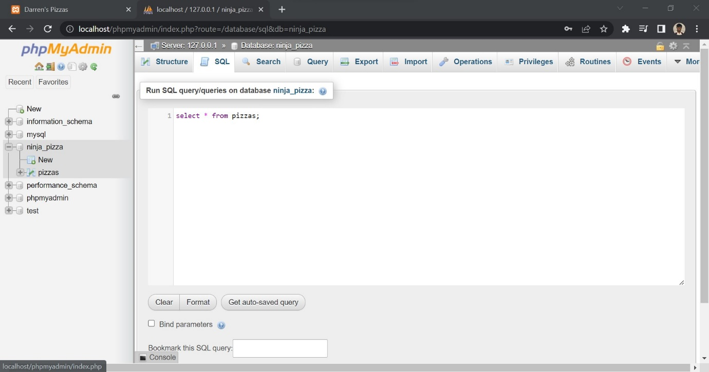

Table in mysql:

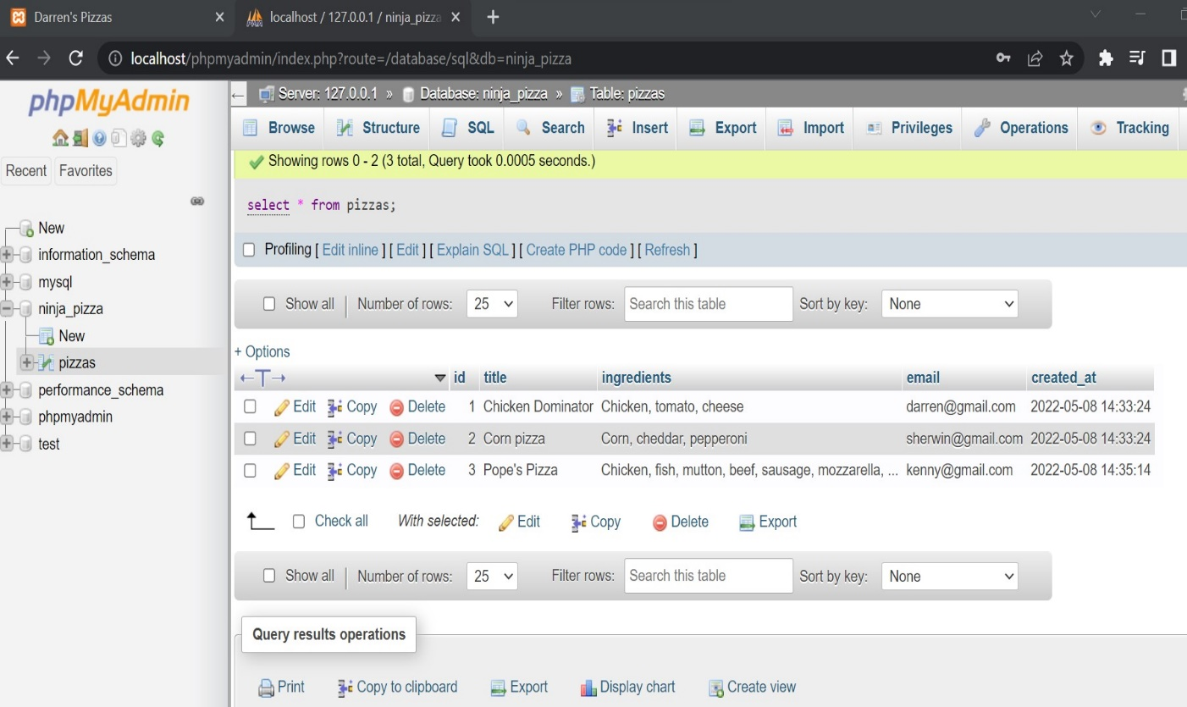

Menu generated on front end:

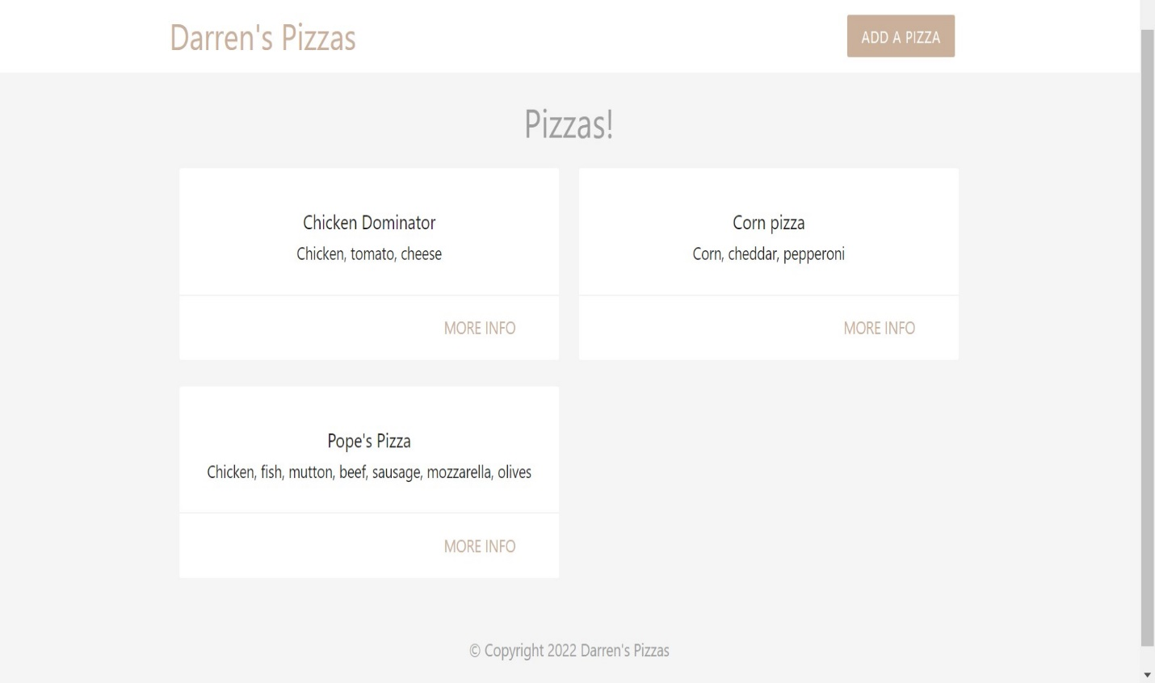

Source code:

1. index.php

<?php

    // connect to the database

    $conn = mysqli_connect('localhost', 'darren', 'Darren1234*', 'darren_pizza');

    // check connection

    if(!$conn){

        echo 'Connection error: '. mysqli_connect_error();

    }

    // write query for all pizzas

    $sql = 'SELECT title, ingredients, id FROM pizzas ORDER BY created_at';

    // get the result set (set of rows)

    $result = mysqli_query($conn, $sql);

    // fetch the resulting rows as an array

    $pizzas = mysqli_fetch_all($result, MYSQLI_ASSOC);

    // free the $result from memory (good practise)

    mysqli_free_result($result);

    // close connection

    mysqli_close($conn);

    print_r($pizzas);

?>

<!DOCTYPE html>

<html>

    <?php include('templates/header.php'); ?>

    <h4 class="center grey-text">Pizzas!</h4>

    <div class="container">

        <div class="row">

            <?php foreach($pizzas as $pizza){ ?>

                <div class="col s6 md3">

                    <div class="card z-depth-0">

                        <div class="card-content center">

                            <h6><?php echo htmlspecialchars($pizza['title']); ?></h6>

                            <div><?php echo htmlspecialchars($pizza['ingredients']); ?></div>

                        </div>

                        <div class="card-action right-align">

                            <a class="brand-text" href="#">more info</a>

                        </div>

                    </div>

                </div>

            <?php } ?>

        </div>

    </div>

    <?php include('templates/footer.php'); ?>

</html>

1. add.php

<?php

    $email = $title = $ingredients = '';

    $errors = array('email' => '', 'title' => '', 'ingredients' => '');

    if(isset($_POST['submit'])){

        // check email

        if(empty($_POST['email'])){

            $errors['email'] = 'An email is required';

        } else{

            $email = $_POST['email'];

            if(!filter_var($email, FILTER_VALIDATE_EMAIL)){

                $errors['email'] = 'Email must be a valid email address';

            }

        }

        // check title

        if(empty($_POST['title'])){

            $errors['title'] = 'A title is required';

        } else{

            $title = $_POST['title'];

            if(!preg_match('/^[a-zA-Z\s]+$/', $title)){

                $errors['title'] = 'Title must be letters and spaces only';

            }

        }

        // check ingredients

        if(empty($_POST['ingredients'])){

            $errors['ingredients'] = 'At least one ingredient is required';

        } else{

            $ingredients = $_POST['ingredients'];

            if(!preg_match('/^([a-zA-Z\s]+)(,\s*[a-zA-Z\s]*)*$/', $ingredients)){

                $errors['ingredients'] = 'Ingredients must be a comma separated list';

            }

        }

        if(array_filter($errors)){

            //echo 'errors in form';

        } else {

            //echo 'form is valid';

            header('Location: index.php');

        }

    } // end POST check

?>

<!DOCTYPE html>

<html>

    <?php include('templates/header.php'); ?>

    <section class="container grey-text">

        <h4 class="center">Add a Pizza</h4>

        <form class="white" action="add.php" method="POST">

            <label>Your Email</label>

            <input type="text" name="email" value="<?php echo htmlspecialchars($email) ?>">

            <div class="red-text"><?php echo $errors['email']; ?></div>

            <label>Pizza Title</label>

            <input type="text" name="title" value="<?php echo htmlspecialchars($title) ?>">

            <div class="red-text"><?php echo $errors['title']; ?></div>

            <label>Ingredients (comma separated)</label>

            <input type="text" name="ingredients" value="<?php echo htmlspecialchars($ingredients) ?>">

            <div class="red-text"><?php echo $errors['ingredients']; ?></div>

            <div class="center">

                <input type="submit" name="submit" value="Submit" class="btn brand z-depth-0">

            </div>

        </form>

    </section>

    <?php include('templates/footer.php'); ?>

</html>

1. header.php

<head>

    <title>Darren's Pizzas</title>

    <!-- Compiled and minified CSS -->

  <link rel="stylesheet" href="https://cdnjs.cloudflare.com/ajax/libs/materialize/1.0.0/css/materialize.min.css">

  <style type="text/css">

      .brand{

        background: #cbb09c !important;

      }

    .brand-text{

        color: #cbb09c !important;

    }

    form{

        max-width: 460px;

        margin: 20px auto;

        padding: 20px;

    }

  </style>

</head>

<body class="grey lighten-4">

    <nav class="white z-depth-0">

    <div class="container">

      <a href="#" class="brand-logo brand-text">Darren's Pizzas</a>

      <ul id="nav-mobile" class="right hide-on-small-and-down">

        <li><a href="#" class="btn brand z-depth-0">Add a Pizza</a></li>

      </ul>

    </div>

  </nav>

1. footer.php

<footer class="section">

    <div class="center grey-text">&copy; Copyright 2022 Darren's Pizzas</div>

</footer>

</body>

Question-2

-Sailors Database

Find the names of sailors who have reserved at least two different boats

SELECT S.sname

FROM Sailors S, Reserves R, Sailors S2, Reserves R2

WHERE S.sid = R.sid

and S2.sid = R2.sid

and S.sid = S2.sid

and R.bid != R2.bid

or

SELECT DISTINCT s.sname FROM sailors s, reserves r1, reserves r2 WHERE s.sid = r1.sid AND r1.sid = r2.sid AND r1.bid <> r2.bid

Find the sids of silors with age over 20 who have not reserved a red boat

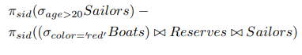

Find the names of sailors who have reserved all boats

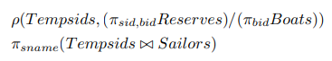

Find the names of sailors who have reserved all boats called Interlake

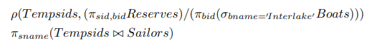

Find all sailors with a rating above 7

* {S | S ? Sailors ^ S.rating > 7}
* Query is evaluated on an instance of Sailors
* Tuple variable S is instantiated to each tuple of this instance in turn, and the condition S.rating > 7 is applied to each such tuple.
* Answer contains all instances of S (which are tuples of Sailors) satisfying the condition

-Movie Database

. List the titles of all movies directed by ‘Hitchcock’.



. Find the movie names where one or more actors acted in two or more movies

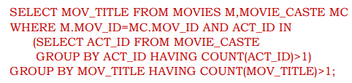

List all actors who acted in a movie before 2000 and also in a movie after 2015 (use JOIN operation).

SELECT ACT_NAME

FROM ACTOR A

JOIN MOVIE_CAST C

ON A.ACT_ID=C.ACT_ID

JOIN MOVIES M

ON C.MOV_ID=M.MOV_ID

WHERE M.MOV_YEAR NOT BETWEEN 2000 AND 201

Find the title of movies and number of stars for each movie that has at least one rating and find the highest number of stars that movie received. Sort the result by movie title.

SELECT MOV_TITLE, MAX (REV_STARS) FROM MOVIES INNER JOIN RATING USING (MOV_ID) GROUP BY MOV_TITLE HAVING MAX (REV_STARS)>0 ORDER BY MOV_TITLE;

Update rating of all movies directed by ‘Steven Spielberg’ to 5.

UPDATE RATING SET REV_STARS=5 WHERE MOV_ID IN (SELECT MOV_ID FROM MOVIES WHERE DIR_ID IN (SELECT DIR_ID FROM DIRECTOR WHERE DIR_NAME = ‗STEVEN SPIELBERG‘));

Citations and references

* <https://github.com/>
* <https://www.apachefriends.org/index.html>
* <https://stackoverflow.com/>

My github repository link:

https://github.com/darr-sherry/Matrix-applications-/tree/DBMS-project